**Extranet User – Application Usage Page**

1. We have created a page named as **ApplicationUsage.aspx**.

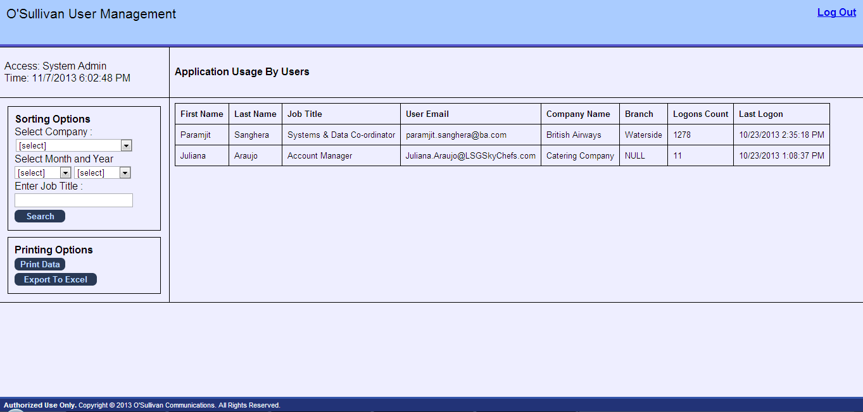

1. We have provided options for Printing and sorting.

**Sorting Options :**

1. Company.
2. Month and Year.
3. Job Title.

**Printing Options :**

1. Print data - Option to print data directly.
2. Export To Excel - Option to download that data as Excel sheet.
3. We are planning to use server-side controls for this page.

**Questions:**

1. There is neither Services nor Database Connectivity’s in this Application to get the Data from database. Here, **ExtranetSecurity2.Dll** file is used to get data.

For ex CoUsers = ExtranetUser.GetListByCompanyID(this.Company1.CompanyID);

How we should access database through **ExtranetSecurity2.Dll** or service?

1. For which Access level users we should show this page?
2. Sorting and Printing Options are enough or you want any changes?